**Card Game Player Project**

Toby Culverwell

Table of Contents

Introduction 3

Card Game Mechanics 3

**Basic Overview** 3

**Card Types** 3

**Game Rules** 3

**Illustrations** 5

Implementation 6

**Players** 6

**Cards** 6

**Runner** 6

Flowcharts and Diagrams 6

**Player** 7

**Support Card** 9

**Creature Card** 10

**Runner** 11

**Class Diagrams** 14

# Introduction

The Card Game Player is a a program written in Java that allows 2 players to play a turn-based trading card game of my own design. This has been chosen as in my free time I play the Yu-Gi-Oh! TCG, therefore I have an interest in games like this. This project will allow me to demonstrate my abilities in Java programming. The program will display everything in text for now, with a more user- friendly display using images to represent cards and actions, a possible update to be implemented at a later point.

# Card Game Mechanics

## **Basic Overview**

The card game is framed as 2 castles (the players) going into battle against each other using their armies (their decks). The win condition is to lay siege to the other castle (reduce their Defense Points to 0) and to do this direct attack with creatures must be made. A direct attack can only be made when your opponent has no creatures on their front line. The card game will be called Castles of Cards.

## **Card Types**

There are 2 categories of Cards: Creature Cards and Support Cards. Each category will be split up into 2 types, so there are 4 types of card. The card types are: Magic Creature, Melee Creature, Magic Support and Item Support. Some Creature cards will also be either ‘Ace’ or ‘Legend’ cards and these cards will be more powerful than most other creature cards, but with the caveat that you can only have 2 Ace Creatures and 1 Legend Creature in your Deck. Creatures will have 2 stats: Health and Attack, with Health relates how much damage a creature can take, while Attack relates how much damage it can inflict.

## **Game Rules**

1. Deck size limit will be 20 minimum and 30 cards maximum.
2. Each player begins with 4000 Defense Points
3. A player’s field consists of 6 zones which are (from right to left): Wasteland zone, 4 Front Line zones and a Deck zone.
4. There is no limit on the size of the hand a player can have.
5. The playing order is determined by coin flip with the player with correct declaration (calls heads and coin lands on heads) going first.
6. At the start of a game, the decks are shuffled and both players draw the top 4 cards of their deck.
7. If a player draws an opening hand without a Creature in it, they can declare a Mulligan and reveal their hand to their opponent and shuffle it back into their deck and redraw their opening hand. Meanwhile, their opponent can draw 1 card from the top of their deck. Repeat until an opening hand with a Creature in it is drawn.
   1. If both players declare a Mulligan, then both players shuffle their hands into their decks and redraw their opening hand.
8. A turn is made up of 4 stages: Draw stage, Plan stage, Battle stage and End stage.
   1. During the Draw stage, the turn player draws the top card of their deck and adds it their hand
   2. During the Plan stage, the turn player can play Support and Creature cards
   3. During the Battle stage, the turn player can attack with the creatures on their Front Line against creatures the other player has on their Front Line or, if the opponent has no creatures on their Front Line, attack directly at the opponent.
   4. The turn ends during the End stage and then the other player gets to play their turn.
9. During the First turn, the battle stage is skipped.
10. When a Support card is played it goes to the Wasteland.
11. Magic Support cards can only be played if the player has a Magic Creature on their Front Line.
12. Item Support cards can only be played if the player has a Melee Creature on their Front Line.
13. When a Creature card’s health is reduced to 0, it goes to the Wasteland.
14. When a Creature attacks another Creature, damage is inflicted by subtracting their attack from the their target’s Health or, if attacking directly, subtracted from the opponent’s Defense Points instead.
15. A Creature can only attack once per turn.
16. If a player cannot draw cards from their deck because there are no more cards, they lose 500 Defense Points during each of their Draw stages that this applies to.

## **Illustrations**

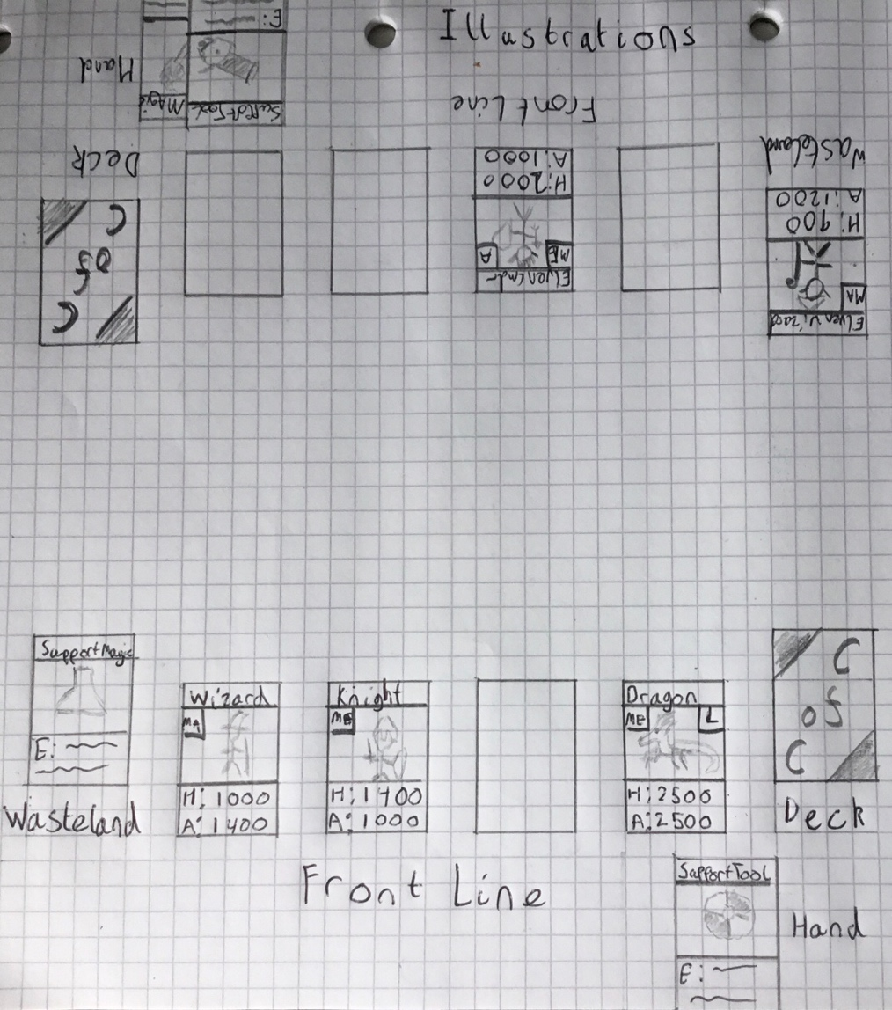Below is an illustrated examples on how the game would look like if it were being played in real life.

# Implementation

## **Players**

Players of the card game will implemented as their own object class with the same name and will have 6 attributes: Name, Defence Points, Wasteland, Front Line, Hand and Deck. The data types for the attributes are: Name will be a String, Defense Points will be an Integer, Wasteland, Hand and Deck will be ArrayLists that stores the Card object and Front Line will be a 4 element Array that stores the Card object.

The Behaviours (methods) that a Player object has are: Drawing from the Deck and Playing Cards from the Hand.

## **Cards**

There will be a parent class of Card in which the 4 card types will inherit from as child classes.

The Card class will have the attributes Name and Card Type, with both being Strings. The Support Card class will have, in addition to the inherited attributes, Effect Description attribute which will be a String. It will also be abstract and each individual Support Card will inherit from the Support Card class as a child class, inheriting all attributes the Support Card has as well as the Effect behaviour. The Creature Card class will have, in addition to inherited attributes, a Health attribute, a Attack attribute and a Skill attribute (the ‘Ace’ or ‘Legend’ aspect of a Creature). The first 2 attributes will be integers, while the Skill attribute will be a String.

The Support Card class will have the behaviour Effect, which is abstract so its child classes can inherit it, while the Creature Card will have the behaviour Attack.

## **Runner**

The Runner will be the java file that is used to run the program that allows the card game to be played. There will be 5 methods in the file with one of them to begin the game, while the rest relating to the 4 stages of a turn (Draw, Plan, Battle, End).

# Flowcharts and Diagrams

The following images are flowcharts for the various methods that the classes and the Runner will have. There are also some Class diagrams which show the relationship between the classes.

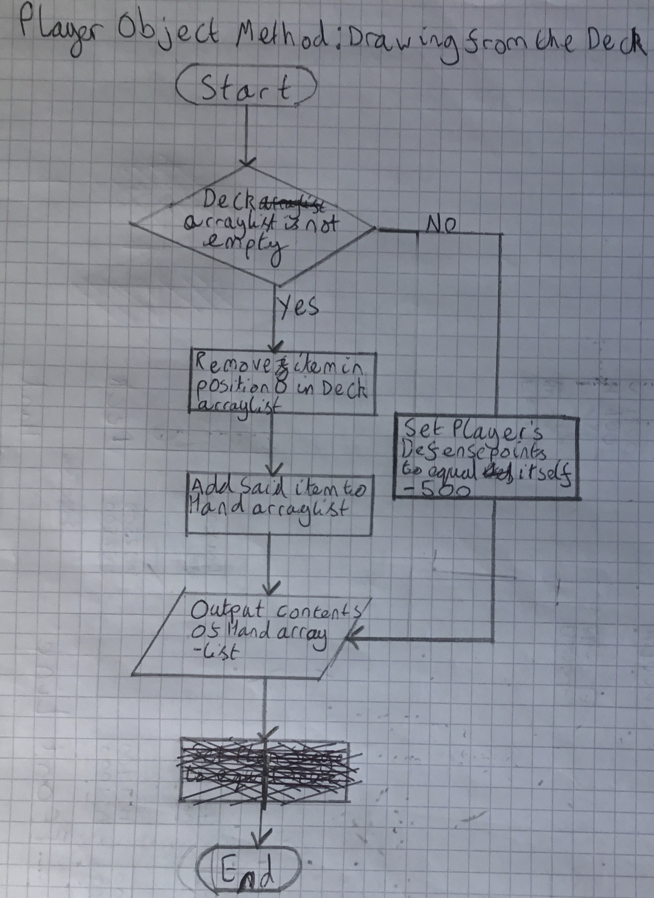**Player**

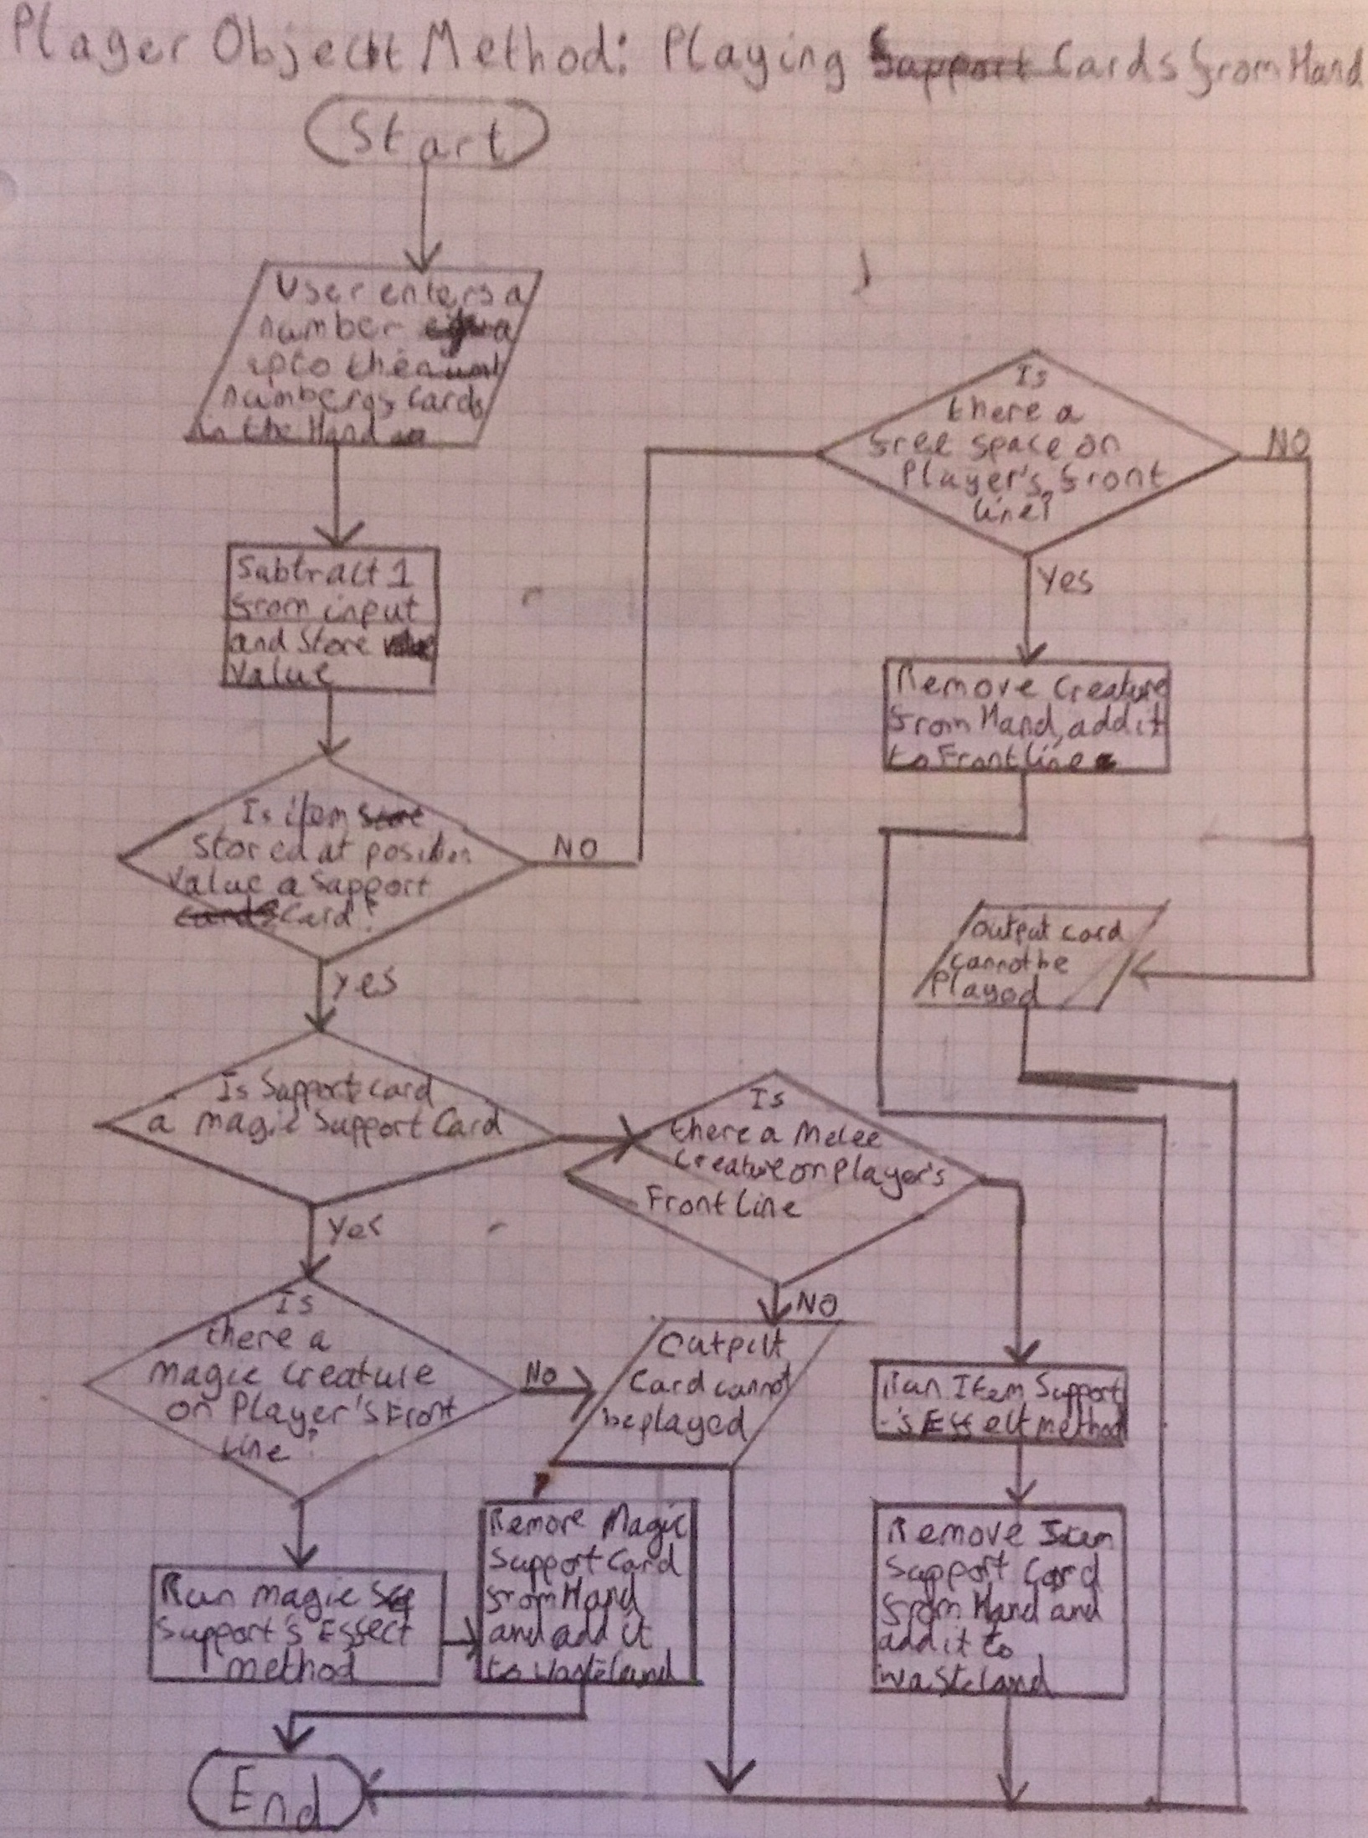

## **Support Card**

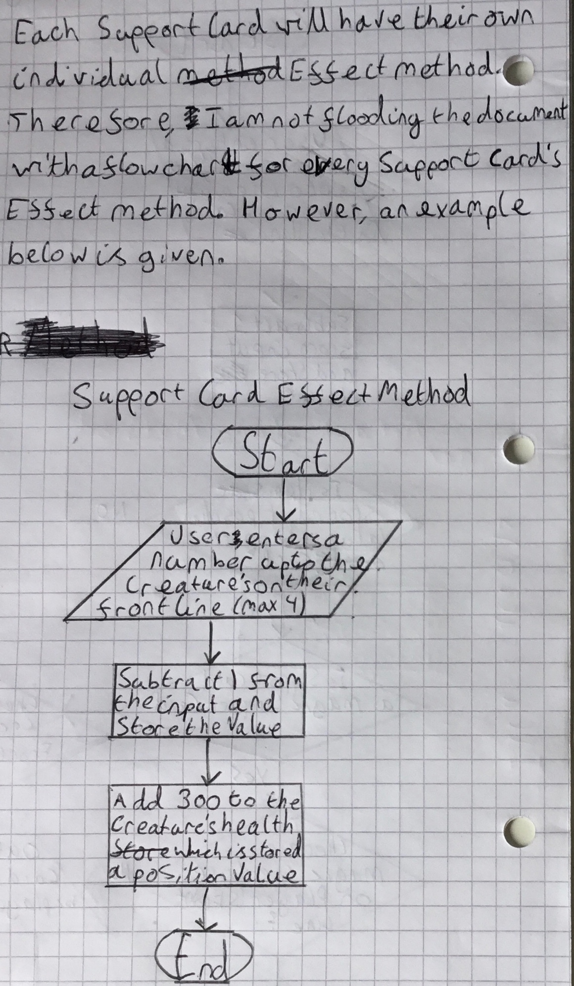

## **Creature Card**

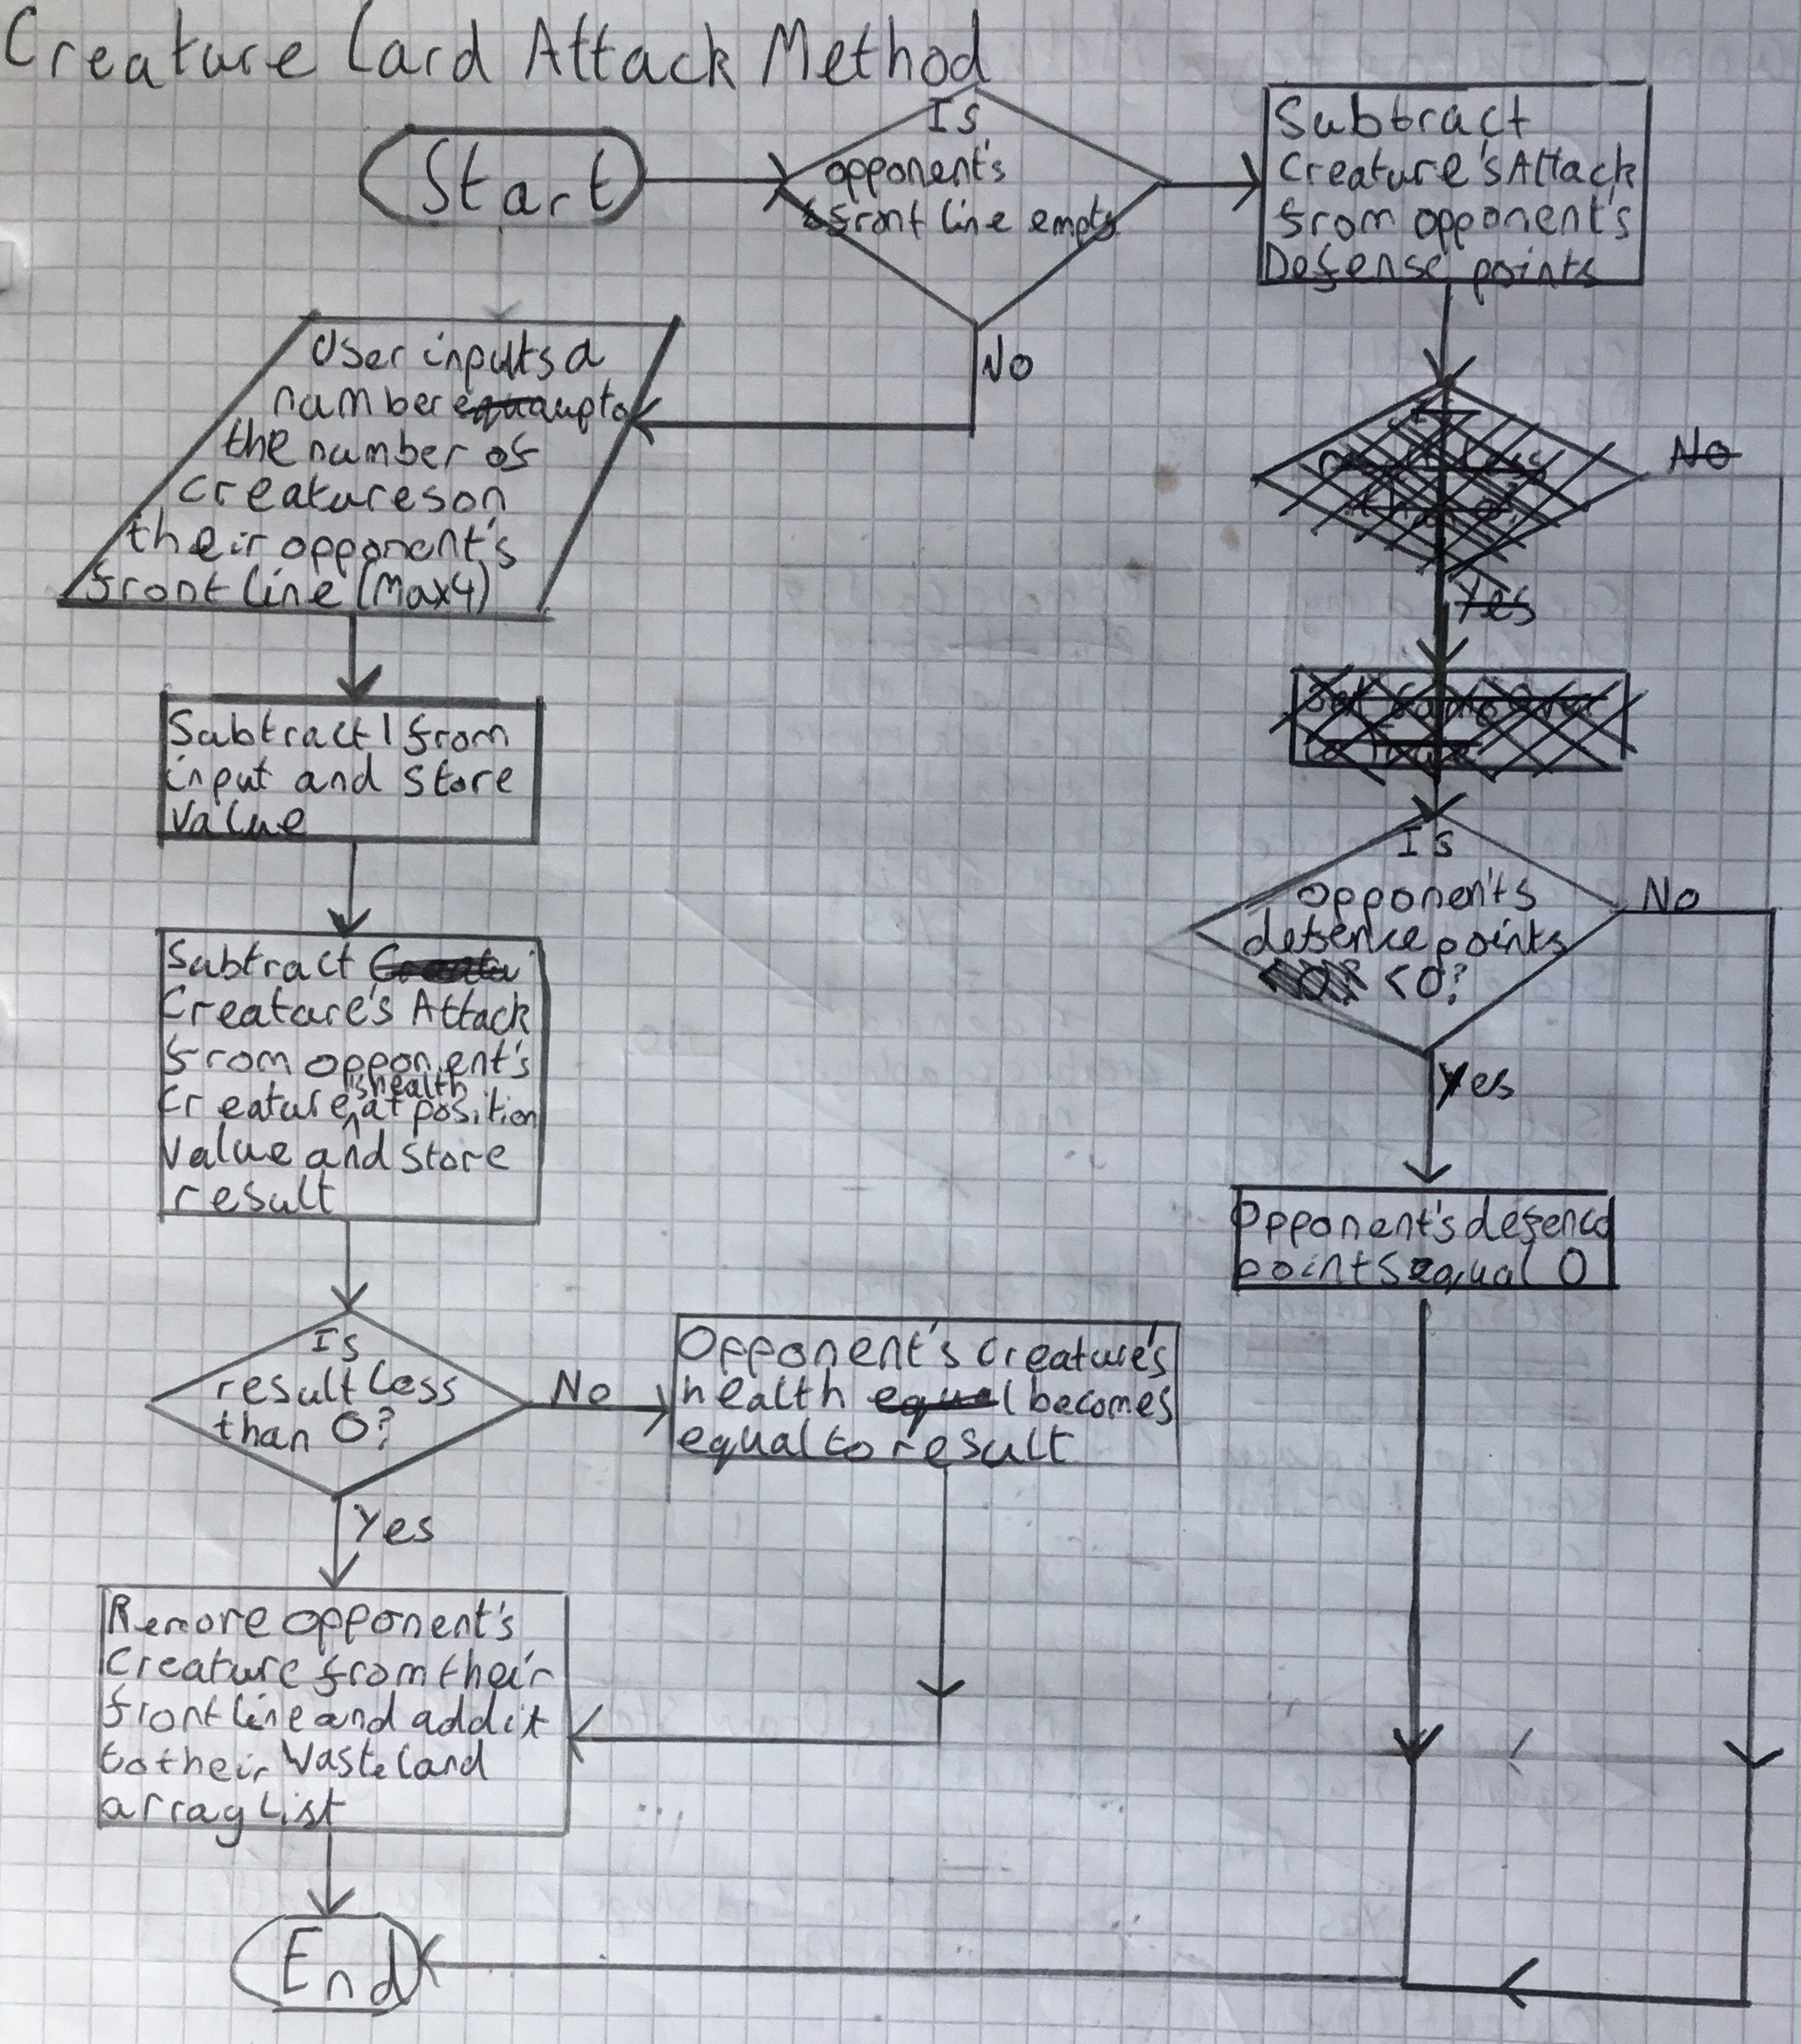

## **Runner**

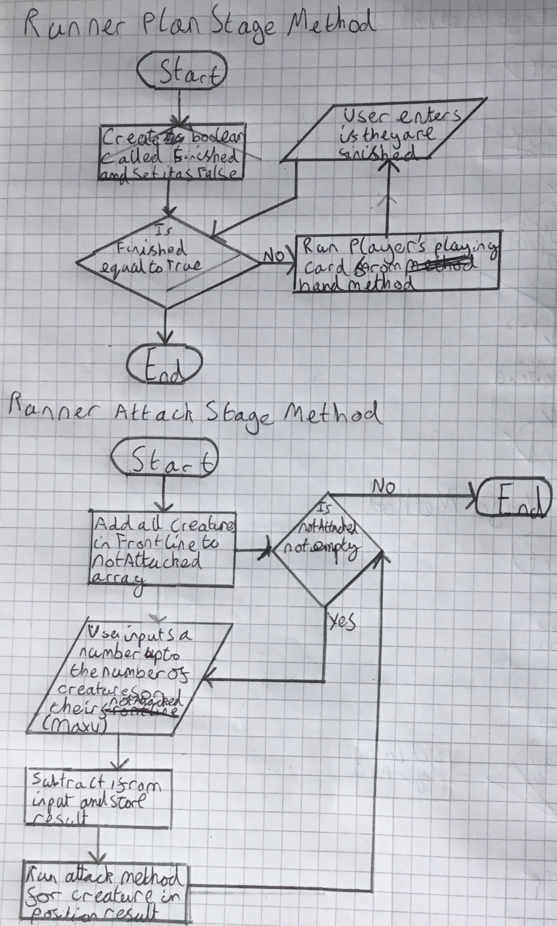

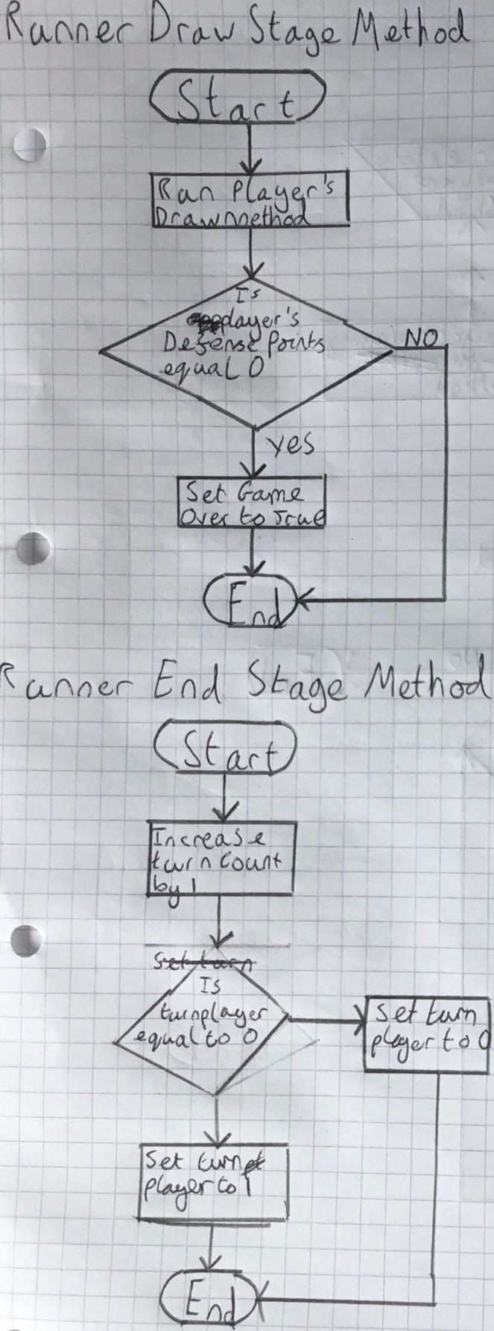

## **Class Diagrams**

